1.
a.
> x=c(53,39,39,33,69,30,25,67,130,94,40)
> x [1] 53 39 39 33 69 30 25 67 130 94 40

b.
> mean(x)[1] 56.27273
> sd(x)[1] 31.96589

Therefore mean is 56.3 and standard deviation is 32.0
c.
> quantile(x) 0% 25% 50% 75% 100%
25 36 40 68 130
Therefore median is 40 and the quartiles are 36 and 68.
d.

See the graph below. It is skewed right.
> hist(x)
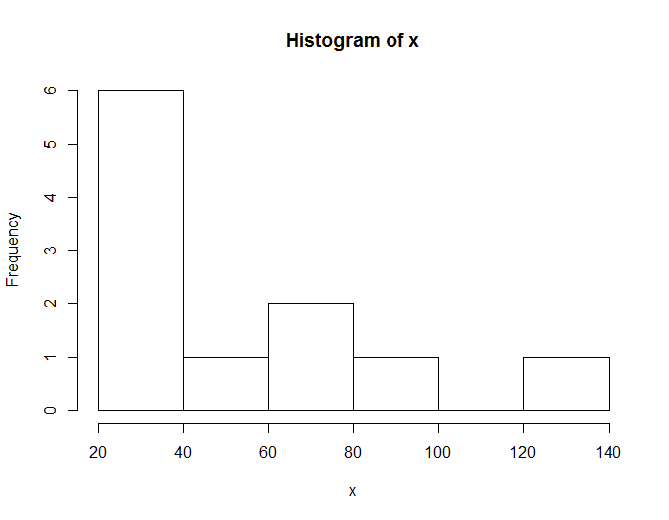
e.
See the graph below. Yes it tells the same thing as the histogram; it is skewed right as well.
> boxplot(x)

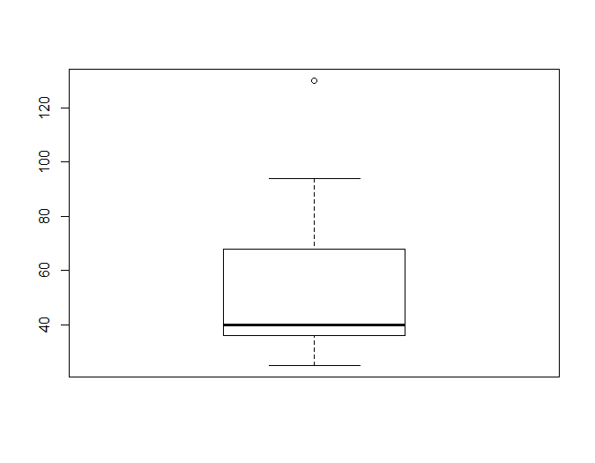

f. I think median and quartiles would be better numerical summary of the data because the outlier does not affect the median as strongly as they do to the mean.

2.
(a)
data coffeemugs;
input brand $ tempdiff;
cards;
sigg 12
sigg 16
sigg 9
sigg 23
sigg 11
sigg 20.5
sigg 12.5
sigg 24.5
starbucks 13
starbucks 7
starbucks 7
starbucks 17.5
starbucks 10
starbucks 15.5
starbucks 6
starbucks 6
cupps 6
cupps 6
cupps 6
cupps 18.5
cupps 10
cupps 17.5
cupps 11
cupps 6.5
nissan 1.5
nissan 2
nissan 3
nissan 0
nissan 7
nissan 0.5
nissan 6
nissan 2
;

proc print;

run;

Results:
Obs | brand | tempdiff
1 | sigg | 12.0
2 | sigg | 16.0
3 | sigg | 9.0
4 | sigg | 23.0
5 | sigg | 11.0
6 | sigg | 20.5
7 | sigg | 12.5
8 | sigg | 24.5
9 | starbuck | 13.0
10 | starbuck | 7.0
11 | starbuck | 7.0
12 | starbuck | 17.5
13 | starbuck | 10.0
14 | starbuck | 15.5
15 | starbuck | 6.0
16 | starbuck | 6.0
17 | cupps | 6.0
18 | cupps | 6.0
19 | cupps | 6.0
20 | cupps | 18.5
21 | cupps | 10.0
22 | cupps | 17.5
23 | cupps | 11.0
24 | cupps | 6.5
25 | nissan | 1.5
26 | nissan | 2.0
27 | nissan | 3.0
28 | nissan | 0.0
29 | nissan | 7.0
30 | nissan | 0.5
31 | nissan | 6.0
32 | nissan | 2.0

(b)
proc means;
var tempdiff;
class brand;

The MEANS Procedure
Analysis Variable : tempdiff
brand | N Obs | N | Mean | Std Dev | Minimum | Maximum
cupps | 8 | 8 | 10.1875000 | 5.2025921 | 6.0000000 | 18.5000000
nissan | 8 | 8 | 2.7500000 | 2.5071327 | 0 | 7.0000000
sigg | 8 | 8 | 16.0625000 | 5.9005902 | 9.0000000 | 24.5000000
starbuck | 8 | 8 | 10.2500000 | 4.5512949 | 6.0000000 | 17.5000000

Nissan has the smallest Standard Deviation, in other words the smallest mean temperature difference hence it appears to be the best mug;
Sigg has the largest Standard Deviation, in other words the largest mean temperature difference hence it appears to be the worst mug.

(c)
proc boxplot;
plot tempdiff*brand / boxstyle=schematic;
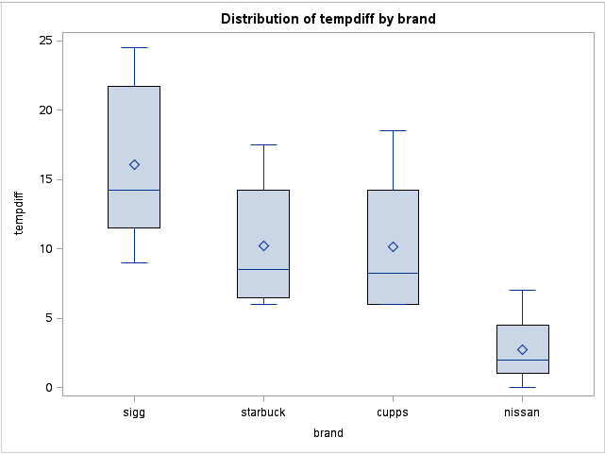
The boxplots do support my conclusions from the means; By looking at the graph we can tell that Nissan has the smallest temperature difference (best) while Sigg has the largest temperature difference (worst); the means are all larger than the medians therefore it is skewed right.

3. (a)
data pop;
infile '/home/victor.xu/pop.txt';
input pgrowth region $ ;

proc print;

Obs | pgrowth | region
1 | 1 | NE/MW
2 | 3 | NE/MW
3 | 4 | NE/MW
4 | 4 | NE/MW
5 | 5 | NE/MW
6 | 5 | NE/MW
7 | 6 | NE/MW
8 | 6 | NE/MW
9 | 7 | NE/MW
10 | 8 | NE/MW
11 | 8 | NE/MW
12 | 9 | NE/MW
13 | 9 | NE/MW
14 | 9 | NE/MW
15 | 9 | NE/MW
16 | 10 | NE/MW
17 | 10 | NE/MW
18 | 11 | NE/MW
19 | 12 | NE/MW
20 | 1 | S/W
21 | 6 | S/W
22 | 9 | S/W
23 | 9 | S/W
24 | 9 | S/W
25 | 10 | S/W
26 | 10 | S/W
27 | 11 | S/W
28 | 11 | S/W
29 | 13 | S/W
30 | 14 | S/W
31 | 14 | S/W
32 | 14 | S/W
33 | 14 | S/W
34 | 15 | S/W
35 | 17 | S/W
36 | 18 | S/W
37 | 20 | S/W
38 | 20 | S/W
39 | 21 | S/W
40 | 21 | S/W
41 | 23 | S/W
42 | 24 | S/W
43 | 26 | S/W
44 | 30 | S/W
45 | 30 | S/W
46 | 31 | S/W
47 | 40 | S/W
48 | 66 | S/W

(b)
data pop;
infile '/home/victor.xu/pop.txt';
input pgrowth region $ ;

proc BOXPLOT;
plot pgrowth*region / boxstyle=schematic;

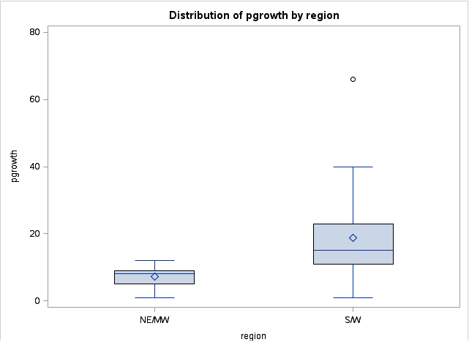

proc means;
var pgrowth;
class region;

The MEANS Procedure
Analysis Variable : pgrowth
region | N Obs | N | Mean | Std Dev | Minimum | Maximum
NE/MW | 19 | 19 | 7.1578947 | 2.9488822 | 1.0000000 | 12.0000000
S/W | 29 | 29 | 18.8620690 | 12.5006404 | 1.0000000 | 66.0000000

S/W has larger mean, median as well as spread. For NE/MW the median is slightly larger than the mean while for S/W the mean is larger than the median and is clearly right skewed because of the outlier.

4.
(a)
wines=read.table("wines.txt",header=T)
Version:1.0 StartHTML:0000000105 EndHTML:0000002283 StartFragment:0000000127 EndFragment:0000002265
> wines CasePrice Location
1 123 Seneca
2 80 Cayuga
3 52 Seneca
4 112 Seneca
5 118 Keuka
6 95 Seneca
7 151 Seneca
8 100 Cayuga
9 66 Seneca
10 143 Keuka
11 110 Seneca
12 115 Seneca
13 70 Seneca
14 78 Seneca
15 103 Seneca
16 92 Seneca
17 118 Seneca
18 131 Keuka
19 115 Cayuga
20 128 Keuka
21 135 Cayuga
22 100 Cayuga
23 75 Seneca
24 105 Seneca
25 90 Seneca
26 72 Cayuga
27 138 Keuka
28 93 Seneca
29 106 Seneca
30 59 Seneca
31 97 Seneca
32 130 Cayuga
33 76 Cayuga
34 88 Cayuga
35 60 Seneca
36 85 Keuka

Same as original data.

(b)
boxplot(CasePrice~Location,data=wines)
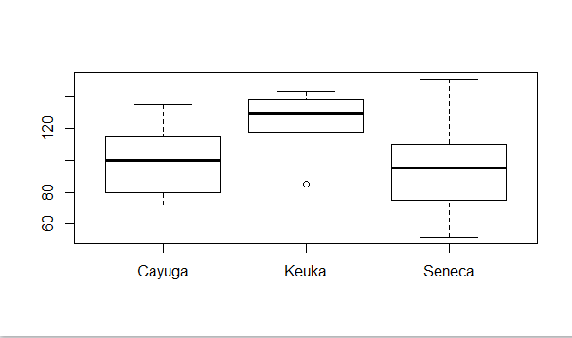
(c)
> aggregate(CasePrice~Location,data=wines,mean) Location CasePrice
1 Cayuga 99.55556
2 Keuka 123.83333
3 Seneca 93.80952

(d) Yes, I think the means provide a fair comparison because both the boxplots and the means tell the same thing: on average keuka wines are most expensive, followed by Cayuga, and Seneca wines are cheapest.
However the boxplots do tell us some additional information:\
- Seneca has the largest price range for wines; it also has the highest price as well as the lowest price.
- Keuka has an outlier; it is much lower than the average price for Keuka.

5. (a)
data crimes;
infile '/home/victor.xu/crime.txt' expandtabs;
input city $ homicide aggass robbery breakent mvtheft theft country $ ;

proc print;

Obs | city | homicide | aggass | robbery | breakent | mvtheft | theft | country
1 | Toronto | 1.7 | 157 | 107 | 553 | 365 | 1692 | Canada
2 | Montreal | 2.1 | 152 | 173 | 1195 | 800 | 2068 | Canada
3 | Vancouve | 2.0 | 164 | 187 | 1430 | 1058 | 4415 | Canada
4 | Calgary | 1.7 | 132 | 105 | 814 | 580 | 2616 | Canada
5 | Edmonton | 2.0 | 180 | 134 | 986 | 539 | 2559 | Canada
6 | Ottawa | 1.0 | 123 | 96 | 690 | 558 | 1835 | Canada
7 | Quebec | 1.7 | 76 | 70 | 925 | 230 | 1771 | Canada
8 | Winnipeg | 2.5 | 276 | 251 | 1228 | 1425 | 2779 | Canada
9 | Hamilton | 1.3 | 144 | 86 | 815 | 698 | 1832 | Canada
10 | LA | 10.6 | 607 | 298 | 636 | 674 | 1726 | USA
11 | NYC | 7.8 | 474 | 372 | 453 | 428 | 1785 | USA
12 | Philadel | 8.1 | 350 | 270 | 507 | 492 | 2199 | USA
13 | Washingt | 7.4 | 265 | 171 | 452 | 484 | 2223 | USA
14 | Detroit | 10.6 | 472 | 229 | 735 | 919 | 2280 | USA
15 | Houston | 7.7 | 433 | 242 | 960 | 645 | 2724 | USA
16 | Boston | 2.1 | . | 106 | 408 | 426 | 1640 | USA
17 | Dallas | 8.5 | 377 | 252 | 1081 | 747 | 3146 | USA
18 | Phoenix | 7.2 | 354 | 170 | 1111 | 1010 | 3524 | USA

(b)
Two things I have noticed:
- For the “city” column, some cities only have part of their full name; (vancouve, piladdel and washingt).
- For the “boston” row, the sign “*” in original data has been replaced by “.”

(c)
proc boxplot;
plot aggass*country / boxtype=schematic;
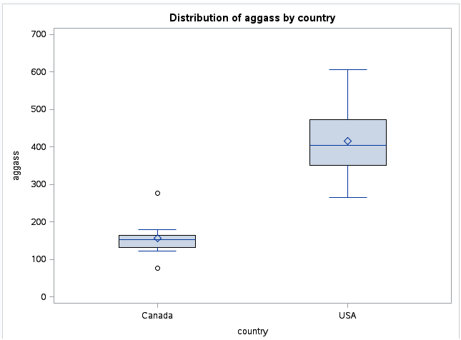

I notice that the aggravated assault rates in the USA is much higher than in Canada (higher mean and median). Also, Canada has a high outlier as well as a low outlier and the high outlier (Winnipeg )somewhat reaches the USA level.

(d)
proc means;
var homicide;
class country;
The MEANS Procedure
Analysis Variable : homicide
country | N Obs | N | Mean | Std Dev | Minimum | Maximum
Canada | 9 | 9 | 1.7777778 | 0.4437842 | 1.0000000 | 2.5000000
USA | 9 | 9 | 7.7777778 | 2.4818228 | 2.1000000 | 10.6000000

By comparing the mean I see that homicide rates are much higher in the USA than in Canada (7.78 compared to 1.78). We can’t tell from this grid whether any of the USA cities look like a
Canadian one when it comes to homicide rates, however we notice the standard deviation for USA is quite large so it is possible.
If we go back to the original data we can see that Boston, which has a homicide rate of 2.1, is clearly at Canada’s level.

6.
(a)
crime=read.csv("CrimeRates.csv",header=T)

City Homocide AggravatedAssault Robbery BreakAndEnter MotorVehicleTheft
1 Toronto 1.7 157 107 553 365
2 Montreal 2.1 152 173 1195 800
3 Vancouver 2.0 164 187 1430 1058
4 Calgary 1.7 132 105 814 580
5 Edmonton 2.0 180 134 986 539
6 Ottawa 1.0 123 96 690 558
7 Quebec 1.7 76 70 925 230
8 Winnipeg 2.5 276 251 1228 1425
9 Hamilton 1.3 144 86 815 698
10 LA 10.6 607 298 636 674
11 NYC 7.8 474 372 453 428
12 Philadelphia 8.1 350 270 507 492
13 Washington 7.4 265 171 452 484
14 Detroit 10.6 472 229 735 919
15 Houston 7.7 433 242 960 645
16 Boston 2.1 NA 106 408 426
17 Dallas 8.5 377 252 1081 747
18 Phoenix 7.2 354 170 1111 1010
Theft Country
1 1692 Canada
2 2068 Canada
3 4415 Canada
4 2616 Canada
5 2559 Canada
6 1835 Canada
7 1771 Canada
8 2779 Canada
9 1832 Canada
10 1726 USA
11 1785 USA
12 2199 USA
13 2223 USA
14 2280 USA
15 2724 USA
16 1640 USA
17 3146 USA
18 3524 USA
>

(b)
boxplot(AggravatedAssault~Country,data=crime)
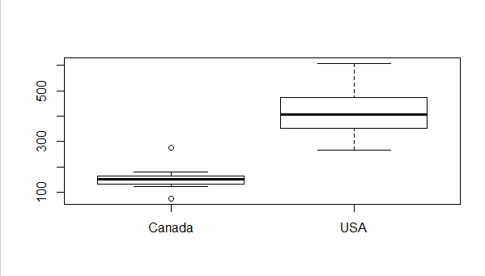
(c)
aggregate(Homocide~Country,data=crime,mean)
Country Homocide
1 Canada 1.777778
2 USA 7.777778

(d)
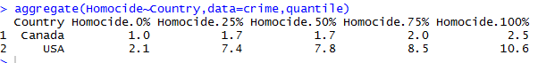

(e)
From SAS the means for Homicide in Canada is 1.777778 and 7.777778 in USA；the maximums are 2.50 and 10.60 and the minimums are 1.00 and 2.10
From R the means for Homocide in Canada is 1.7 and 7.8 in USA; the maximums are 2.6 and 10.6 and the minimums are 1.00 and 2.10.
Therefore yes, the R and SAS produce the same answers.

7.
(a)
> cholesterol=read.csv("Cholesterol.csv",header=T)> cholesterol
Smokers Ex.Smokers
1 225 250
2 211 134
3 209 300
4 284 249
5 258 213
6 216 310
7 196 175
8 288 174
9 250 328
10 200 160
11 209 188
12 280 321
13 225 213
14 256 257
15 243 292
16 200 200
17 213 271
18 246 227
19 225 238
20 237 163
21 232 263
22 267 192
23 232 242
24 216 249
25 216 242
26 243 267
27 200 243
28 155 217
29 216 267
30 271 218
31 230 217
32 309 183
33 183 228
34 280 NA
35 217 NA
36 305 NA
37 287 NA
38 217 NA
39 246 NA
40 351 NA
41 200 NA
42 280 NA
43 209 NA

The first column is the Cholesterol measurements for smokers and the second column is the Cholesterol measurements for ex-smokers.

(b)
> cholesterol2=stack(cholesterol)> cholesterol2
values ind
1 225 Smokers
2 211 Smokers
3 209 Smokers
4 284 Smokers
5 258 Smokers
6 216 Smokers
7 196 Smokers
8 288 Smokers
9 250 Smokers
10 200 Smokers
11 209 Smokers
12 280 Smokers
13 225 Smokers
14 256 Smokers
15 243 Smokers
16 200 Smokers
17 213 Smokers
18 246 Smokers
19 225 Smokers
20 237 Smokers
21 232 Smokers
22 267 Smokers
23 232 Smokers
24 216 Smokers
25 216 Smokers
26 243 Smokers
27 200 Smokers
28 155 Smokers
29 216 Smokers
30 271 Smokers
31 230 Smokers
32 309 Smokers
33 183 Smokers
34 280 Smokers
35 217 Smokers
36 305 Smokers
37 287 Smokers
38 217 Smokers
39 246 Smokers
40 351 Smokers
41 200 Smokers
42 280 Smokers
43 209 Smokers
44 250 Ex.Smokers
45 134 Ex.Smokers
46 300 Ex.Smokers
47 249 Ex.Smokers
48 213 Ex.Smokers
49 310 Ex.Smokers
50 175 Ex.Smokers
51 174 Ex.Smokers
52 328 Ex.Smokers
53 160 Ex.Smokers
54 188 Ex.Smokers
55 321 Ex.Smokers
56 213 Ex.Smokers
57 257 Ex.Smokers
58 292 Ex.Smokers
59 200 Ex.Smokers
60 271 Ex.Smokers
61 227 Ex.Smokers
62 238 Ex.Smokers
63 163 Ex.Smokers
64 263 Ex.Smokers
65 192 Ex.Smokers
66 242 Ex.Smokers
67 249 Ex.Smokers
68 242 Ex.Smokers
69 267 Ex.Smokers
70 243 Ex.Smokers
71 217 Ex.Smokers
72 267 Ex.Smokers
73 218 Ex.Smokers
74 217 Ex.Smokers
75 183 Ex.Smokers
76 228 Ex.Smokers
77 NA Ex.Smokers
78 NA Ex.Smokers
79 NA Ex.Smokers
80 NA Ex.Smokers
81 NA Ex.Smokers
82 NA Ex.Smokers
83 NA Ex.Smokers
84 NA Ex.Smokers
85 NA Ex.Smokers
86 NA Ex.Smokers

The first column now shows all Cholesterol measurements while the second column shows the identity (whether the person is a smoker or ex smoker)

(c)
I use the original data.
hist(cholesterol$Smokers)
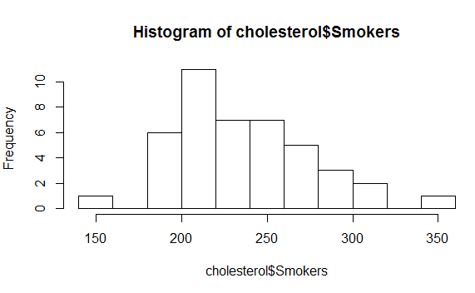
And

hist(cholesterol$Ex.Smokers)
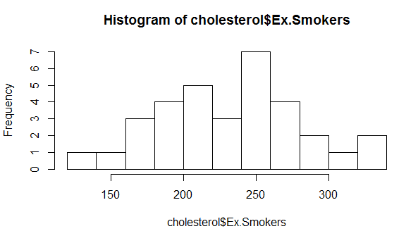

(d) I use the new data.
boxplot(values~ind,data=cholesterol2)
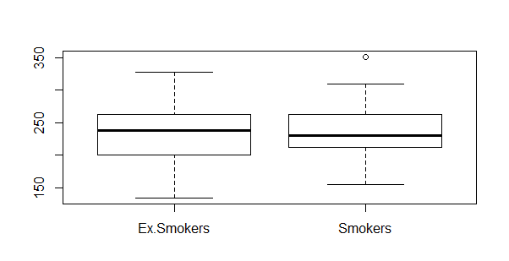

(e) Ex.Smokers group has larger spread and a bit higher medium while the smokers group has an oulier. Nothing really that notable.

(f) overall Ex.Smokers group has larger spread however the means seem to be close.
Therefore the conclusions are consistent with the ones from the boxplot.

(g) I think boxplot is easier to compare because you can see the spread, medium and maximum&minimums easily; you can also see outliers.

